Agenda- To integrate JIRA with Pega and to manage it from PEGA

For this first we need to navigate ti the PEGA marketplace and download..

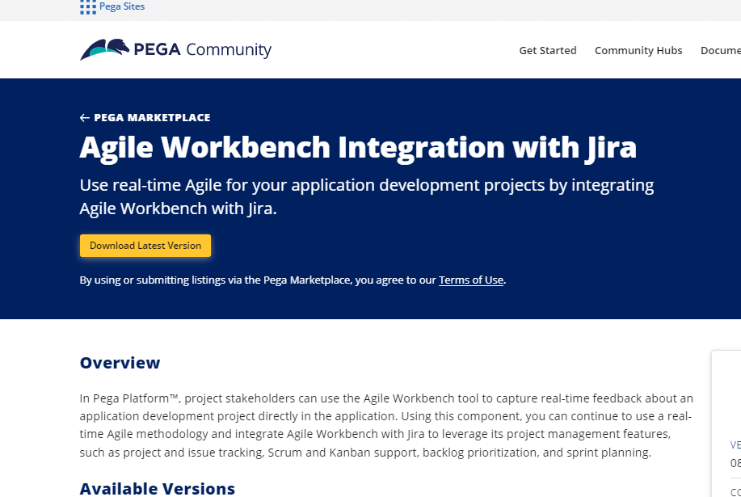

After downloading Import the zip file and after import Log Off and Log In again.

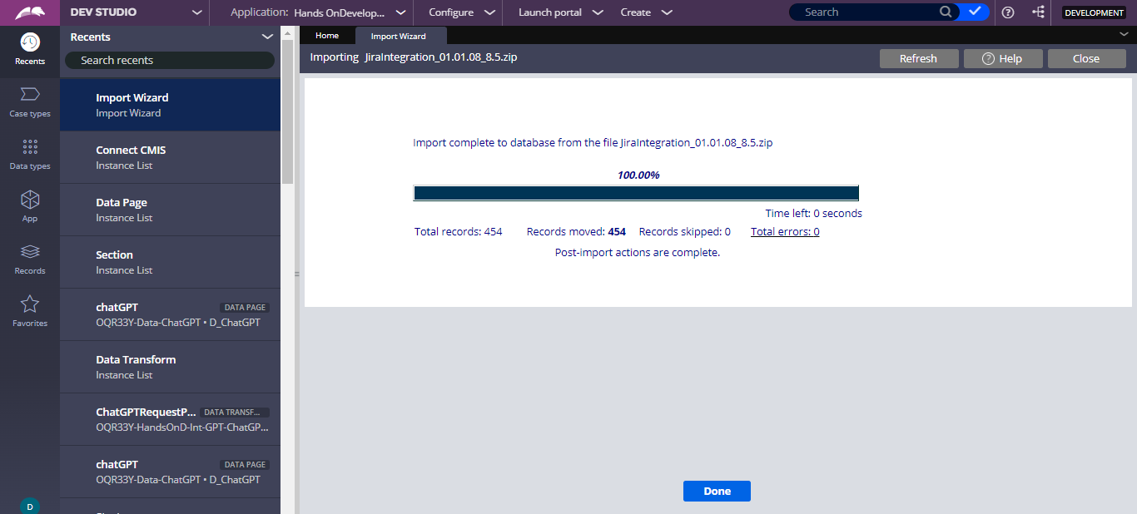

After that go to the application definition; and components and enable the components and click OK.

And save the application rule.

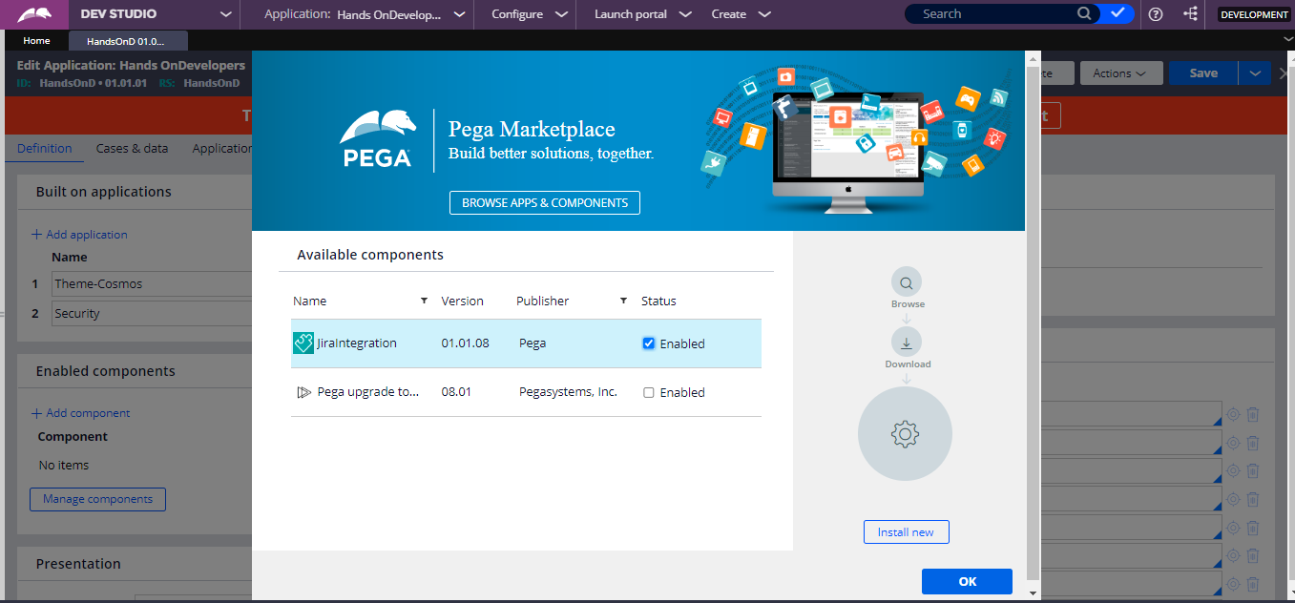

After that got to <https://id.atlassian.com/login> and login/sign up for account and then the below screen appears and then go Click on “Get it Free”

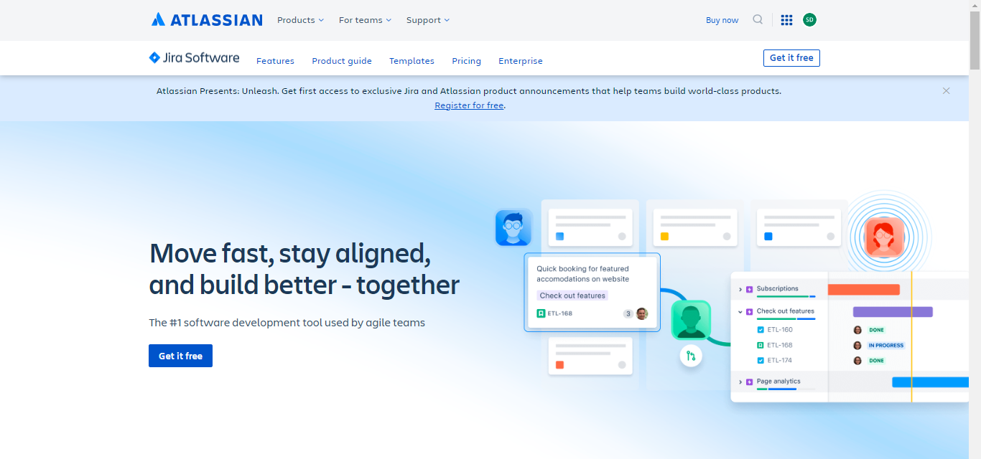

And then

And then give your email and

And then the above screen appears and then go for the selection of the project temaplate and select Company manged project…

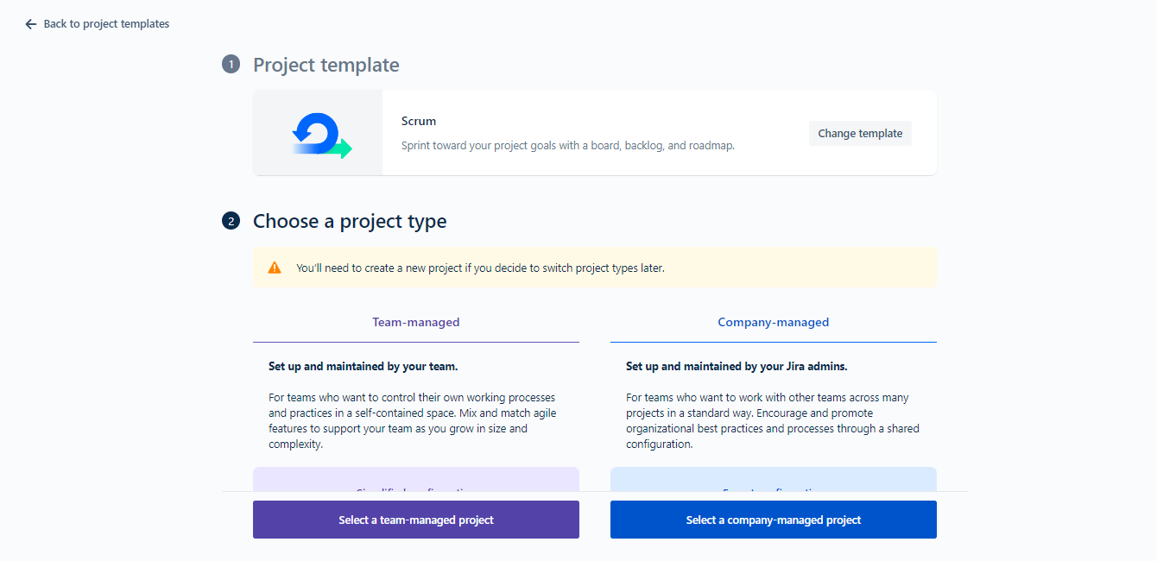

And then create releases and then go for the creation of version and after that on the top left go for the Releases and create one version…

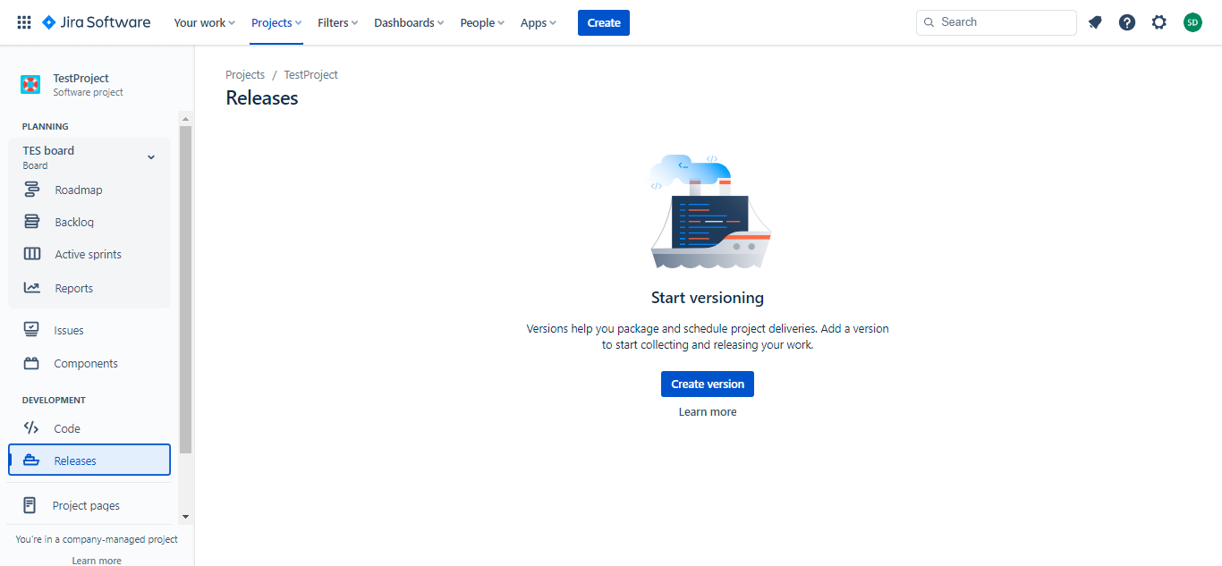

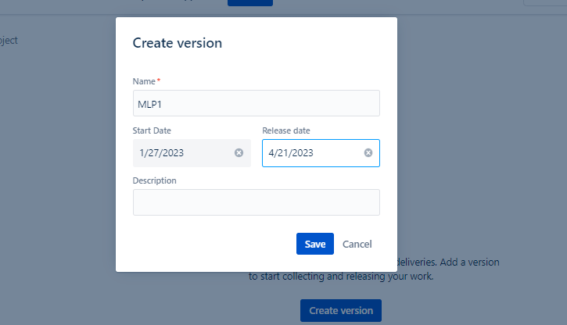

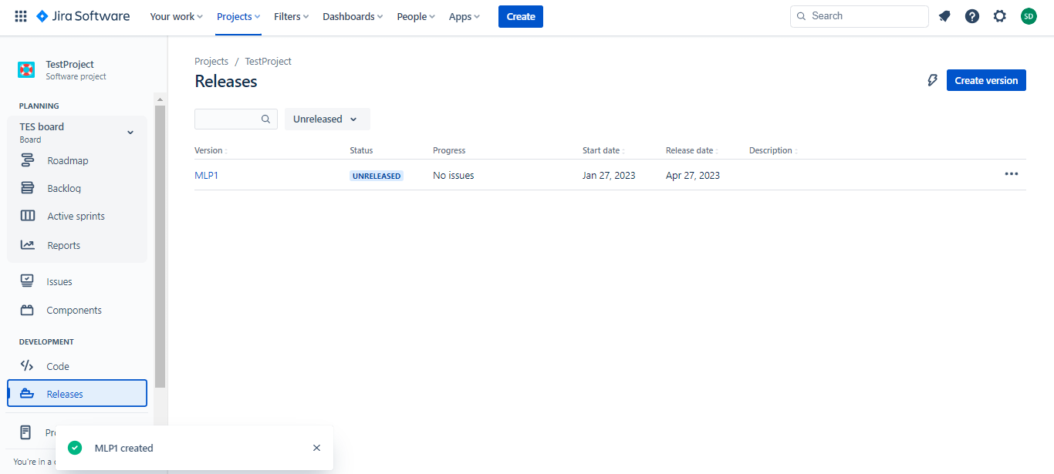

After creation of version use the following URL for the API key <https://id.atlassian.com/manage-profile/security/api-tokens> and create API token as below…

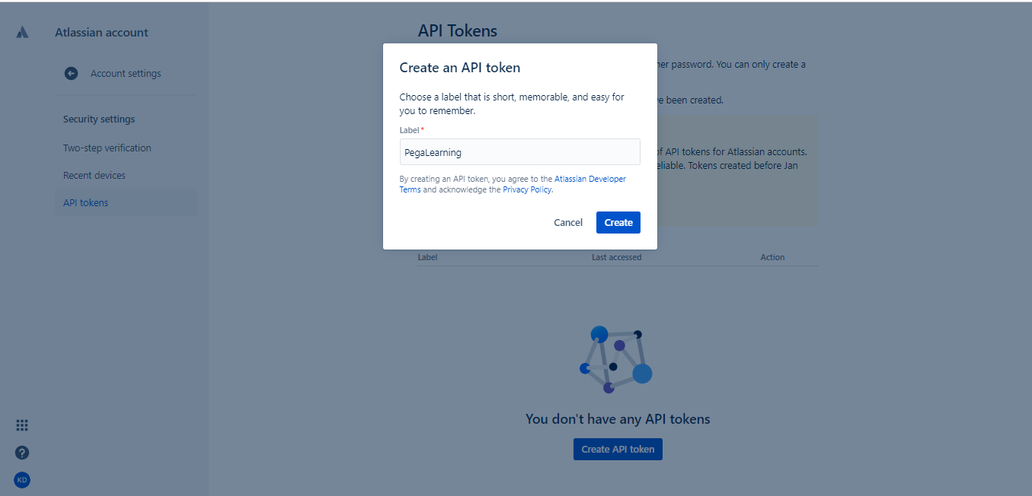

And then go to the Authentication Profile and search for the PM_Auth_Jira Profile

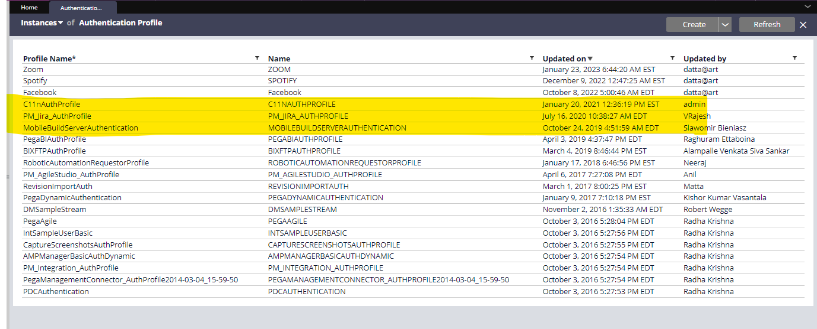

And in this, we have the PM-JIRA Auth profile which comes with the internal component…

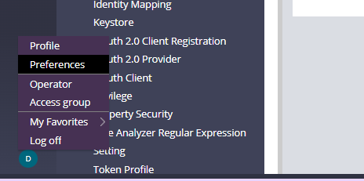

Now update in the preferences tab the User ID and thenn use the

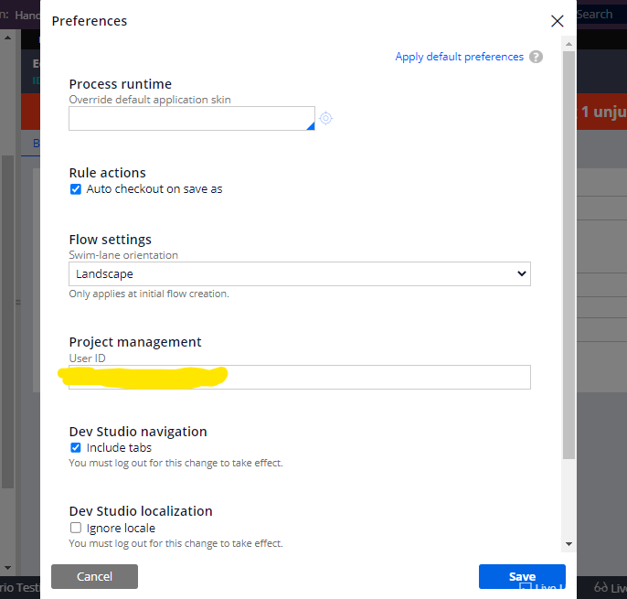  
  
and then go to application definition under integration and security add the agile workbench integration and select JIRA

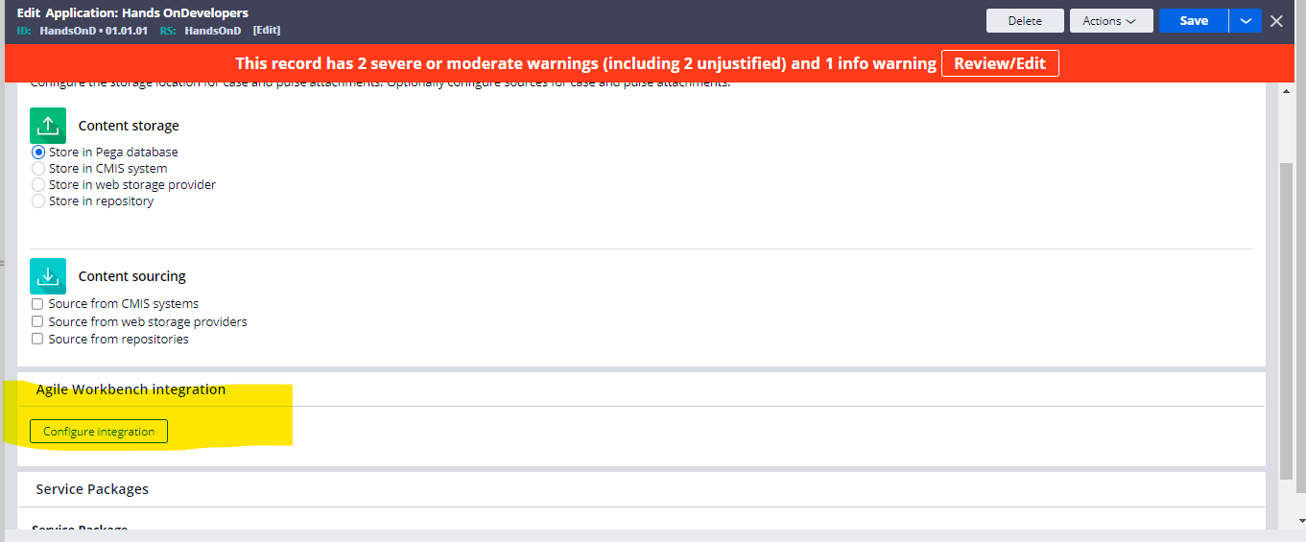

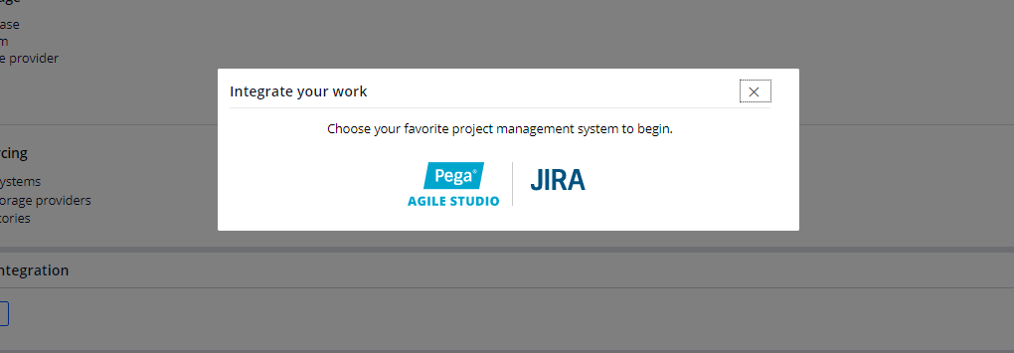

And in the setup integration details in place of Your Jira paste the user name

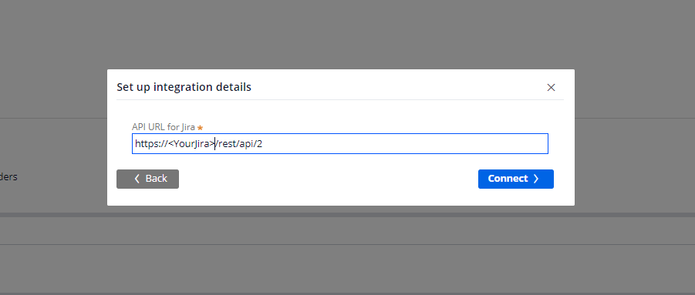

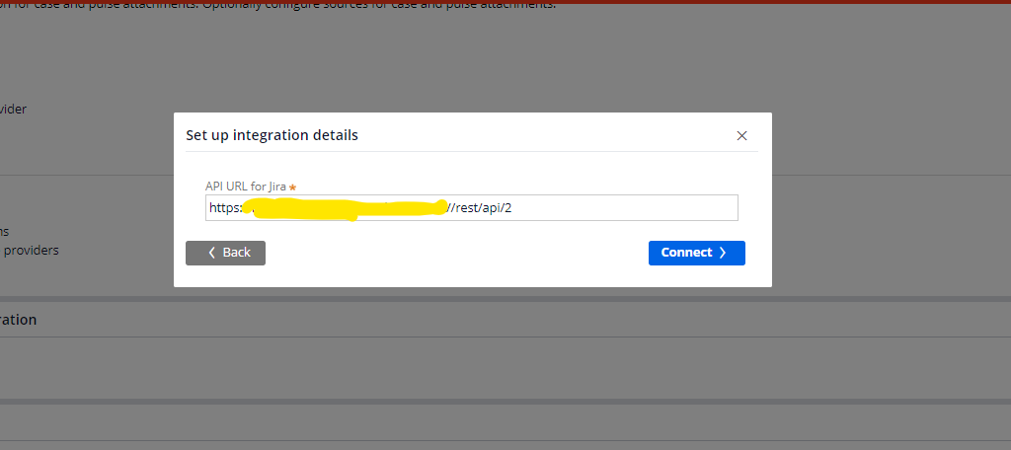

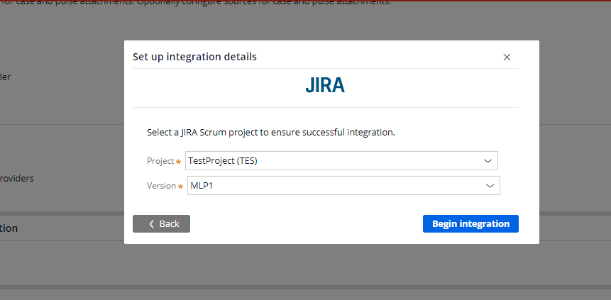

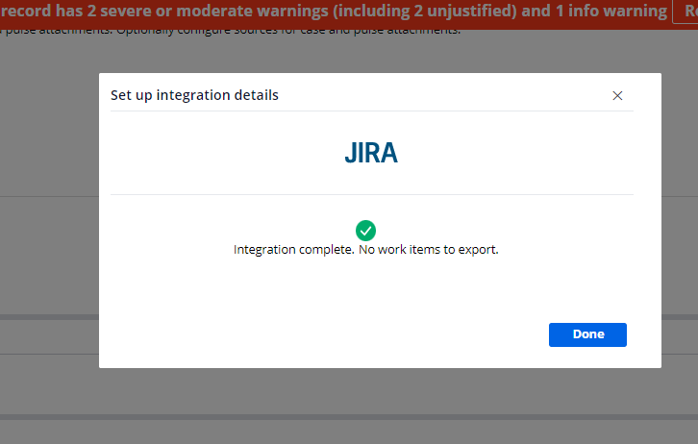

And after that give the project and version and submit after the successful integration keep as done..

Then switch to app studio and then click on the agile workbench icon and create a story it will reflect in the Jira scrum board

